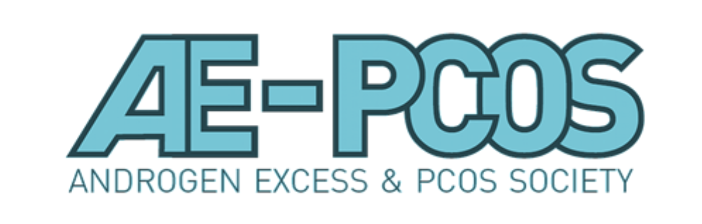

19th ANNUAL MEETING OF THE ANDROGEN EXCESS & PCOS SOCIETY

NOVEMBER 12-14
1-5PM EST
VIRTUAL PLATFORM

DRAFT PROGRAMME

Day 1, November 12th, 1-5pm EST
Time | Speaker | Topic
1:00 pm (EST) | Kathleen Hoeger University of Rochester, Rochester, NY, USA, President of the AEPCOS Society  Rebecca Campbell University of Otago, Dunedin, New Zealand, Chair of the Annual Meeting Committee | Welcome and Overview: AEPCOS Annual Meeting 2021
Session 1: PCOS in adolescence
1:15 pm | Chris McCartney University of Virginia Health, Charlottesville, Virginia, USA | PCOS ontogeny in adolescence
1:40 pm | Maria Trent Johns Hopkins University, Baltimore, Maryland, USA | Management of PCOS in adolescents
2:05 pm | Lisa Moran Monash University, Melbourne, Australia | Lifestyle approaches for the adolescent with PCOS
2:30 pm | Moderator: TBA | Q&A: Session 1
Presidential Lecture
2:40 pm | Kathleen Hoeger  University of Rochester, Rochester, NY, USA | Presidential Lecture: xx
3:10 pm | Moderator: Lisa Stener-Victorin | Q&A: Presidential Lecture
3:15-3:45 COFFEE BREAK and INTRACTIVE POSTER SESSION
Session 2: Oral Presentations 1: Clinical and Basic Research
3:45 pm | TBA
3:55 pm | TBA
4:05 pm | Moderator: Terhi Piltonen | Q&A:Oral Presentations
Session 3: Debate: PCOS is an inflammatory disorder
4:15 | Barbara Obermayer, Medical University of Graz, Graz, Austria | Will speak AGAINST the motion for:
4:30 | Frank Gonzales, University of Illinois, Chicago, IL, USA | Will speak IN SUPPORT OF the motion for:
4:45 | Moderator: Joop Laven | Debate, Discussion and Possible Motion

Day 2, November 13th, 1-5pm EST
Time | Speaker | Topic
1:00 pm (EST) | Kathleen Hoeger  University of Rochester, Rochester, NY, USA  President of the AEPCOS Society | Introduction and Welcome to Day 2
Session 4: Lessons from pre-clinical models of PCOS
1:05 pm | Nathalie Di Clemente, Sorbonne Université-INSERM, Paris, France | New spontaneous rat model of PCOS
1:30 pm | W Colin Duncan, The University of Edinburgh, Edinburgh, Scotland | FGF21 deficit and PCOS
1:55 pm | Moderator: Rebecca Campbell, University of Otago, Dunedin, New Zealand | Q&A: Session 4
Session 5: Oral Presentations 2: Clinical and Basic Research
2:05 pm | TBA
2:15 pm | TBA
2:25 pm | TBA
2:35 pm | TBA
2:45 pm | Moderator: Anju Joham | Q&A:Oral Presentations
3:55-3:25 COFFEE BREAK and INTRACTIVE POSTER SESSION
Session 6: Early Career Special Interest Group Event
3:25 | Introduction | EC-SIG Event
3:35 |  | Break out groups
3:35 |  | Break out groups
3:35 |  | Break out groups
4:00 | Report Back/Discussion | Break out groups
Award Lecture: Walter Futterweit Clinical Research Excellence Award
4:20 | Evanthia Diamanti-Kandarakis, University of Athens, Greece | Clinical Research Award Lecture:
4:50 | Moderator: Anuja Dokras | Q&A: Clinical Research Award Lecture

Day 3, November 14th
Time | Speaker | Topic
1:00 pm (EST) | Kathleen Hoeger, University of Rochester, Rochester, NY, USA  President of the AEPCOS Society | Introduction and Welcome to Day 3
Session 7: Treatment of PCOS through central mechanisms
1:05 pm | Richard Anderson, University of Edinburgh, Scotland | Targeting Neurokinin B in PCOS treatment
1:30 pm | Waljit Dhillo, Imperial College London, UK | Therapeutic potential of kisspeptin
1:55 pm | Moderator: Paulo Giacobini (TBC) | Q&A: Session 7
Session 8: Advocacy and Oral Communciations 3: Clinical Research
2:05 | Sasha Ottey PCOS Challenge, The National Polycystic Ovary Syndrome Association, USA | PCOS Advocacy
2:20 | TBA
2:30 | TBA
2:40 | Moderator: Tania Burgert | Q&A: Session 8
2:50-3:05 COFFEE BREAK and POSTERS
Session 9: PCOS: Diet and Inflammation
3:05 pm | Jorge Chavarro Brigham and Women’s Hospital, Harvard Medical School, USA | The influence of diet on PCOS
3:30 pm | Karina B Gomes Federal University of Minas Gerais, Brazil | Pro and Anti-inflammatory markers in PCOS
3:55 pm | Moderator: Poli Mara Spritzer | Q&A:Session 8
Award Lecture: Ricardo Azziz Distinguished Researcher Award
4:05 | David Abbott Wisconsin National Primate Research Centre, USA | Distinguished Researcher Award Lecture: Nonhuman primate models of PCOS pathogenesis
4:35 | Moderator: Ricardo Azziz, Albany NY, USA | Q&A: Distinguished Career Award Lecture
4:45 | Anuja Dokras | AE-PCOS Society Update and meeting wrap up

